WalkieOne v30 Manufacturer Handoff
  - Complete prototype build and assembly
Current design baseline v30 | Handoff H1 | 21 September 2026
Use this package to fabricate and assemble one complete WalkieOne v30 enclosure prototype. The build includes the printed enclosure, button mechanisms, retained electronics, bonded metal grille, acoustic seals and USB liner. All quantities are per complete unit.
Release status: ready for prototype printing and physical assembly evaluation. Functional acceptance requires the checks in this guide. Production durability, drop and ingress performance are not qualified.
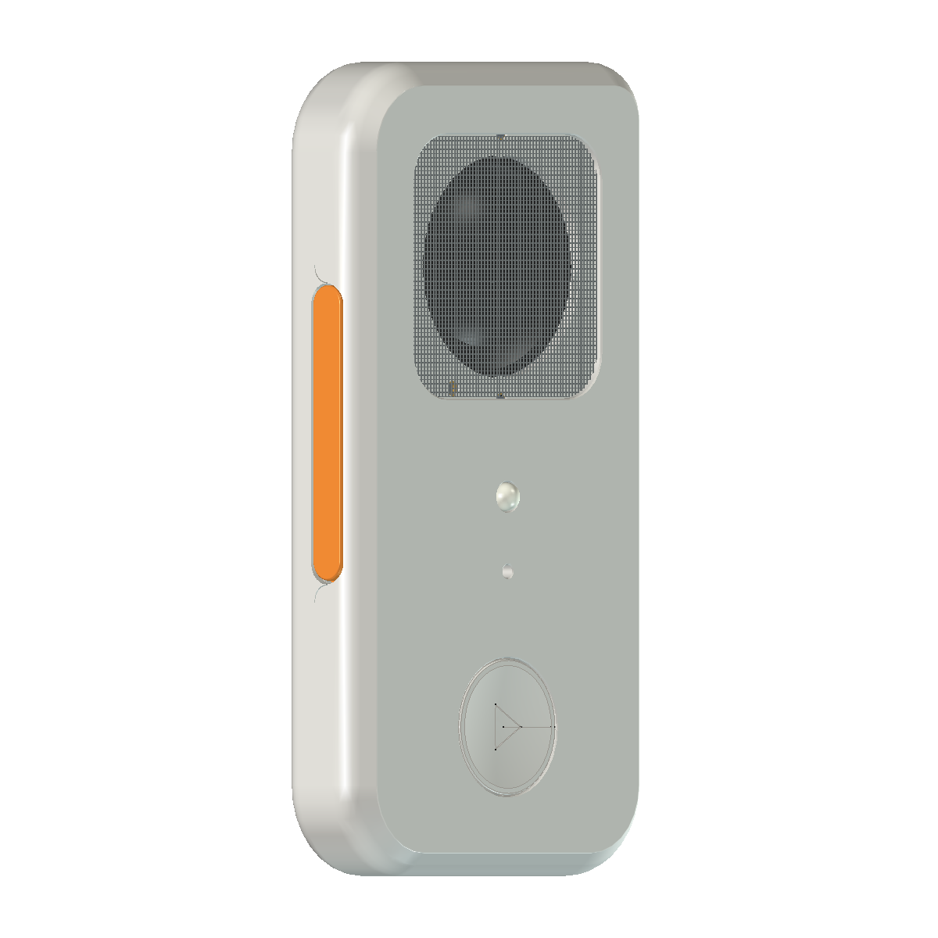
Supplied v30 CAD view. Colors distinguish parts; all printed pieces use one white PLA+ filament.
Body width | Body height | Body thickness
73.5 mm | 143.25 mm | 19.4 mm

The body envelope excludes the LED lens and volume-button projections. CAD views are identification references, not dimensioned inspection drawings.
Source: Source package README.md and verification/RELEASE-CHECK.json. Geometry is unchanged in this handoff.

Package use and build sequence

Start with these files
00_Handoff contains this guide in PDF and editable Word format, the Parts and Build Record workbook, and a supplier handoff message. 01_Source_Package contains the complete, unchanged v30 source folder. 02_Package_Verification records the fresh integrity check and file inventory.
Need | Use within the v30 source folder
Print the prototype | print-projects/01-Case.3mf through 05-Volume.3mf
Individual printable parts | print/ with 21 ready-oriented STL files
Inspect the complete assembly | WalkieOne-v30-finished-case.FCStd
Neutral printable-part geometry | cad/WalkieOne-v30-printed-parts.step
Cut grille, adhesive and seals | templates/ and templates/usb/
Check source evidence | verification/ and SHA256SUMS.json

Complete build order
1. Confirm the component identities and materials in the procurement list. Print all five projects and inspect the parts.
2. Prepare templates, metal grille, seals, adhesive pads and the USB liner stock. Install and cool the inserts before installing electronics.
3. Bond the grille, then fit the speaker with its gasket, washers and spacers. Assemble the PTT mechanism and route its upper wire before seating the cassette and LED assembly.
4. Build the volume and play modules. Install microphone and LED. Complete their wiring using the confirmed electrical plan.
5. Dry-fit the PCB, battery and USB collar. Fit the USB liner in the sequence given in this guide and secure the harness clear of moving parts.
6. Inspect with the case open, close gently, repeat the functional checks, and complete the build record.

Document and geometry control
The supplied v30 files define the current geometry and print placement. Read the saved 3MF projects as projects in Bambu Studio. Keep all v30 components together. The Word file is editable; the PDF is the issued H1 reading copy. Record any proposed change against the affected file and obtain a design disposition before incorporating it into a build.
Source scripts and their original machine paths are retained for traceability. They are not a portable build system and are not needed to print the released projects. Reference electronics and wire envelopes in CAD are assembly references, not printable parts or an electrical schematic.
Source: README.md, PRINTING.md, ASSEMBLY.md and source package structure.

Exterior identification
Use these supplied CAD views to identify the controls and openings before assembly. Dimensions come from the native assembly and the values in this guide; do not scale the illustrations.
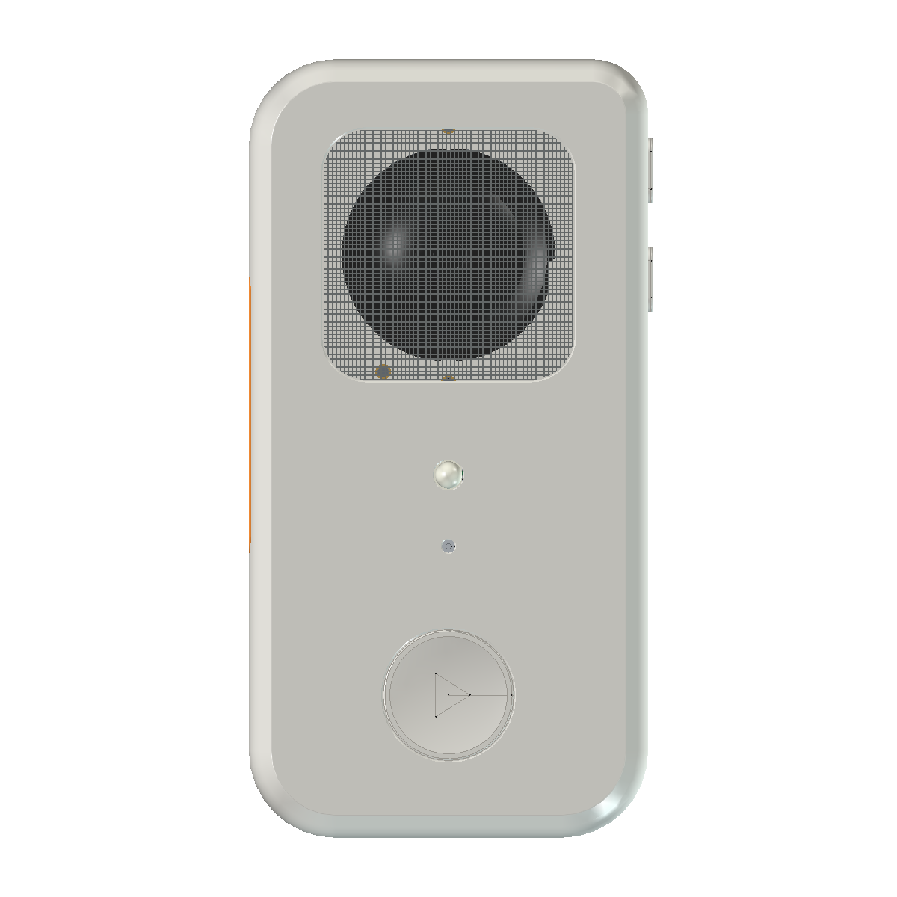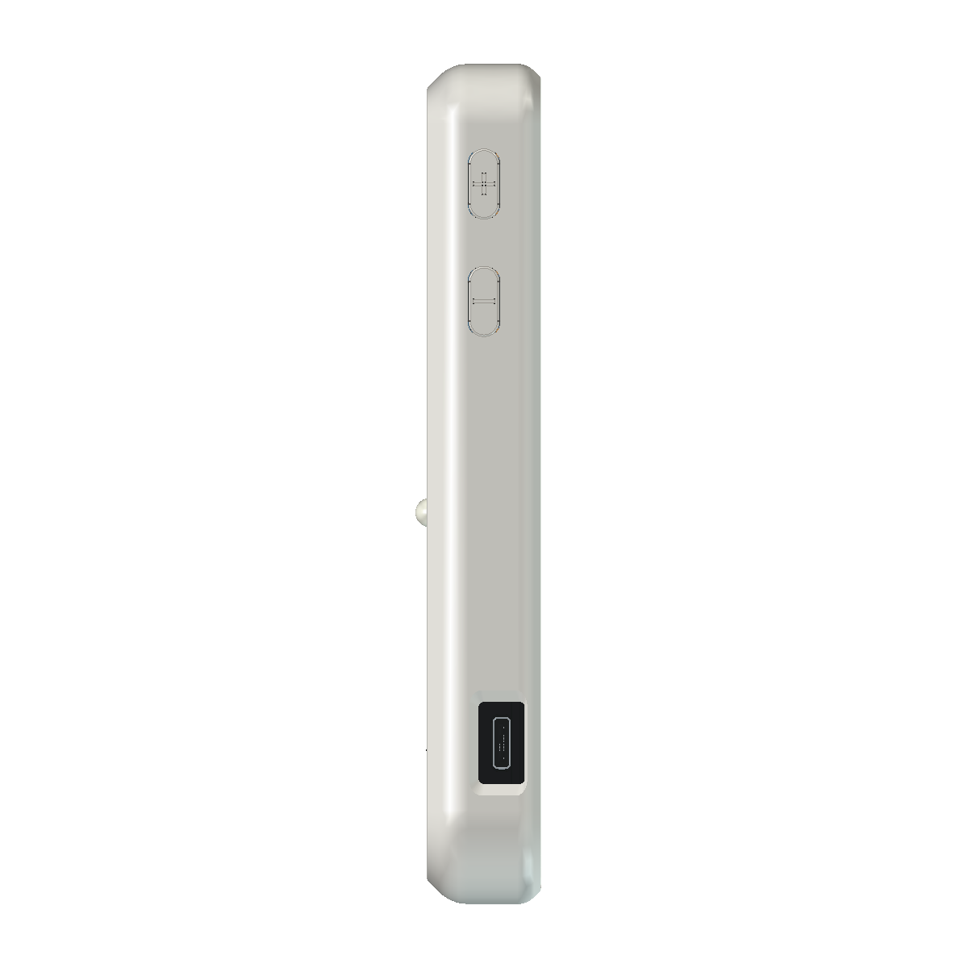
Front face | Right side
From top to bottom: bonded grille and speaker, LED lens, microphone inlet, play cap. | From top to bottom: volume up, volume down, recessed USB opening and opaque liner.

The long PTT cap is on the opposite side. Its narrow curved seam is an assembly clearance. Keep the microphone inlet, grille acoustic area and USB throat unobstructed.
The body is 73.5 mm wide x 143.25 mm tall x 19.4 mm thick, excluding the LED lens and volume-button projections. These are nominal reference dimensions; no general manufacturing tolerance is assigned by this package.
Source: images/front-final.png, images/right-side-final.png and README.md.

Printed parts list
Print one of each file below except Speaker_spacer_07.stl, which needs two. The five projects already contain all 22 pieces. Do not add a second pair of spacers when using the complete small-parts project.
ID | STL filename | Qty | Project
P01 | Front.stl | 1 | 01-Case
P02 | Back.stl | 1 | 01-Case
P03 | PTT_cap.stl | 1 | 02-PTT
P04 | PTT_Link_1.stl | 1 | 02-PTT
P05 | PTT_Link_2.stl | 1 | 02-PTT
P06 | PTT_Pivot_sleeve_moving_1.stl | 1 | 02-PTT
P07 | PTT_Pivot_sleeve_moving_2.stl | 1 | 02-PTT
P08 | PTT_Pivot_sleeve_fixed_1.stl | 1 | 02-PTT
P09 | PTT_Pivot_sleeve_fixed_2.stl | 1 | 02-PTT
P10 | PTT_switch_seat.stl | 1 | 02-PTT
P11 | PTT_switch_retainer.stl | 1 | 02-PTT
P12 | Play_cap.stl | 1 | 03-Play-button
P13 | Play_carrier_C.stl | 1 | 03-Play-button
P14 | Play_retainer_C_040.stl | 1 | 03-Play-button
P15 | LED_retainer.stl | 1 | 04-Small-parts
P16 | USB_collar.stl | 1 | 04-Small-parts
P17 | Speaker_spacer_07.stl | 2 | 04-Small-parts
P18 | Volume_guide_frame.stl | 1 | 05-Volume
P19 | Volume_rear_seat.stl | 1 | 05-Volume
P20 | Volume_down_cap.stl | 1 | 05-Volume
P21 | Volume_up_cap.stl | 1 | 05-Volume

The complete printed bill is 21 unique files and 22 pieces. CAD reference parts such as electronics, metal, adhesive, gaskets and fasteners are supplied separately.
Source: verification/RELEASE-CHECK.json plate object lists, reconciled to print/ filenames.

Printing process
Project | Pieces | Estimated time | PLA estimate
01-Case | 2 | 8 h 1 min | 72.0 g
02-PTT | 9 | 2 h 20 min | 5.7 g
03-Play-button | 3 | 1 h 35 min | 6.3 g
04-Small-parts | 4 | 28 min | 0.8 g
05-Volume | 4 | 50 min | 1.5 g

Total source slicer estimate: 13 h 13 min and 86.4 g, including each plate startup. These are machine estimates; assembly labor, failed prints and material allowance are additional.

Printer setup
Bambu Lab A1 mini; stock 0.4 mm nozzle; Textured PEI plate; one white PLA+ spool; no AMS. Open each numbered 3MF as a project and select Slice plate. Preserve orientation, scale, nozzle, blockers, per-object settings and saved profiles. The projects do not contain ready-to-run G-code.
Saved temperatures are 220 °C nozzle and 60 °C bed. Shells use 0.12 mm layers, a 0.20 mm first layer, four walls, eight top/bottom layers, and 40 / 80 mm/s outer / inner walls. Front solid infill preserves the fine USB details; retain the saved Back infill.
Mechanisms and small parts use 0.08 mm layers, four walls and a 0.20 mm first layer. Outer walls are 30 mm/s except the play project at 40 mm/s. Play flow ratio is 0.92169; the other projects use 0.98. Keep zero XY hole and contour compensation and avoid ironing on moving or mating faces.

Support removal
Case: exterior faces remain toward the bed. Remove support from the hidden Front grille recess without deepening the seat. Back is support-free. The plate texture transfers to the exterior faces.
PTT: retain saved supports and brims. Keep cassette mounting slots clear. Peel supports in small sections; preserve pivot bores, bearing faces, pusher, switch-contact face, sleeve shoulders and stops.
Play and small parts: support-free in their saved orientations. Keep the identification dots. Volume: retain frame and keeper supports, remove them from the exterior sides and protect all four thin retaining tongues. Caps print without supports.
Let each plate cool before removal. Cut brim and strings rather than flexing retainers. Remove stray burrs only; do not sand functional datums to change fit or travel. Inspect and record print defects before assembly.
Source: PRINTING.md and verification/RELEASE-CHECK.json. Slicer verification is supplied evidence, not a fresh reslice in this handoff.

Hardware and insert installation
Mount | Qty | M2 insert length | M2 screw length | Head form
Case closure | 4 | 4 mm | 12 mm | Low pan head
Play holder | 2 | 4 mm | 8 mm | Low pan head
LED holder | 2 | 4 mm | 6 mm | Low pan head
PTT moving pivots | 2 | 4 mm | 8 mm | Socket head with shoulder sleeve
PTT fixed pivots | 2 | 4 mm | 6 mm | Socket head with shoulder sleeve
PTT cassette | 2 | 4 mm | 8 mm | Low pan head
Speaker | 2 | 2 mm | 4 mm | Low pan head
Microphone | 2 | 2 mm | 4 mm | Low pan head
Volume module | 2 | 2 mm | 5 mm | Low pan head

Per unit: 14 inserts at 4 mm long and 6 inserts at 2 mm long. Screws total 20: four at 12 mm, six at 8 mm, four at 6 mm, two at 5 mm and four at 4 mm. The workbook separates screw lengths by head form.

Insert geometry and installation
The specified M2 insert geometry matches the Ktehloy kit: maximum knurl diameter 3.2 mm and pilot end 2.7 mm. Printed insert bores are nominally 2.9 mm. Install inserts before electronics, keep them flush at their mounting faces and let them cool completely.
PTT pivot screws tighten against printed shoulder sleeves so the links can move freely. Other mounts use the low pan-head bearing arrangement. Countersunk screws are incompatible with these bearing faces. Confirm actual head dimensions against the CAD before substitution.

Speaker hardware stack
At each of the two speaker mounts, assemble from the screw head toward the front: screw head → 0.7 mm printed spacer → speaker tab → 0.3 mm metal washer → flush short insert. Each washer is 2.2 mm ID and 5 mm OD. The spacers are included in the printed parts count.

Assembly process to establish
Insert installation temperature, tightening torque and a repeatable fastening process are not specified. Establish them on representative printed samples with the actual inserts and screws, and record the chosen process. Do not use fastener force to correct an unseated component or trapped harness.
Source: ASSEMBLY.md Hardware and Grille and speaker; verification/independent-assembly-review.md Hardware accounting.

Materials and electronic components
Material | Per unit | Required geometry or fit
Metal grille | 1 | 46 x 46 x 0.50 mm; R8 corners
Grille adhesive | 1 ring | F9473PC, 0.26 mm without liner; use relieved perimeter template
Volume adhesive | 2 pads | F9473PC, 4 x 4 x 0.26 mm each
Speaker gasket | 1 | 0.5 mm soft stock; approximately 0.3 mm assembled; use template
Microphone gasket | 1 | 5.6 mm OD / 2.6 mm ID; 0.5 mm stock; 0.4 mm assembled
Play body pads | 4 | Approximately 1 x 1.8 mm; 0.5 mm stock; approximately 0.3 mm assembled
LED soft pad | Optional | Fit actual axial gap; 0.5 mm nominal
USB PET liner | 1 set | 3M 1350F-1; 0.064 mm total per layer; nominal templates

Electronics required for a complete unit
Supply one main PCB with USB receptacle, one battery, one speaker, one microphone, one LED, one play switch, one PTT switch and two volume switches. Match the electronic reference geometry in the native FreeCAD assembly.
PTT uses a LIDUOLE 6 x 6 x 6 mm switch. Volume uses 6 x 6 x 4.3 mm switches. The play switch must match Play_switch_reference and the C carrier / C-0.40 retainer assembly. Envelope similarity alone does not establish compatible actuation or terminals.
Confirm exact ordering part numbers, PCB revision, battery and component ratings, pinout and harness before electrical assembly. Local CAD wire allowances do not define a complete wiring plan. The workbook contains blank fields for actual supplier, part number and received quantity.

Template control
Use the original SVG/DXF templates at 100% actual size. Check the 20 mm grille scale bar and 10 mm USB calibration square. Do not use images embedded in this guide as cut templates. Material grades for the soft seals and the grille alloy, finish and perforation pattern require selection.
Source: ASSEMBLY.md, USB-ASSEMBLY.md and templates/. Quantities refer to one new complete build.

Grille and speaker assembly
1. Cut and deburr the grille blank to 46 x 46 mm, R8 corners and 0.50 mm finished overall thickness. Use Grille_metal_reference.svg. The displayed CAD grid is illustrative; select a real perforation pattern with a supported bonding perimeter.
2. Remove hidden-seat support scars without changing seat depth. Dry-fit from the outside. Nominal side clearance is 0.25 mm per side; the grille top sits nominally 0.79 mm below the front surface. It should enter evenly without force.
3. Cut the F9473PC perimeter ring using Grille_bond_reference.svg, preserving its vent reliefs. Remove the release liner. The nominal grille plus adhesive stack is 0.76 mm. Thick foam mounting tape changes the stack and is not the specified material.
4. Confirm adhesion on a coupon using the actual printed PLA+, finish and metal. Prepare clean, dry surfaces and apply firm, even pressure around the supported perimeter. Keep adhesive out of the sound opening, insert-tip vents and side clearance. Avoid pushing unsupported mesh toward the speaker.
5. Fit the speaker centered at CAD X36 / Y106.5, with its mounting ears above and below it. Use the two M2 x 4 mm screws, short inserts, printed spacers and metal washers in the stack on the hardware page.
6. Fit the soft acoustic sealing ring, cut from 0.5 mm stock to seat at approximately 0.3 mm without distorting the speaker. The grille adhesive and acoustic gasket serve separate functions; both are required.

Acceptance and service
Record coupon adhesion, even seating, clear vents, acoustic sealing and speaker operation. Perforations reduce effective bond area; the CAD outline does not prove the usable bonding area or adhesive strength. Check the chosen grille rather than assuming a solid-sheet bond.
For service, remove the speaker before working behind the grille, then replace the adhesive after grille removal. Preserve the support shelf and printed shell. The removable case joint remains unbonded.
Source: ASSEMBLY.md Grille and speaker; verification/independent-assembly-review.md Bonded grille. Adhesive dimensions are the source design reference, not a newly qualified material process.

PTT mechanism assembly
The PTT uses a 52 mm cap, two parallel links, four shoulder sleeves and the matching seat / retainer cassette. The mechanism is springless. Use the files in the 02-PTT project for a new build.
1. Inspect the cap, links, sleeve shoulders, pivot bores, pusher, stops and mounting slots after support removal. Keep their printed dimensions.
2. Fit the moving sleeves and links to the cap using two M2 x 8 mm socket-head screws and the moving-pivot inserts. Tighten onto the sleeves while leaving the links free.
3. Enter the cap assembly through the open back. Fit the fixed sleeves with two M2 x 6 mm socket-head screws and fixed-pivot inserts. Confirm that both links remain free through travel.
4. Fit the LIDUOLE 6 x 6 x 6 mm switch into the holder pair. Verify the electrically connected and switched terminal pairs before preparing the wiring.
5. Route the upper wire through the cassette channel before seating the cassette and LED assembly. The channel is 2.6 mm in the source review. Keep both wire exits and slack clear of links and cap ends.
6. Install the cassette with two M2 x 8 mm screws. Upper and lower mount locations are CAD X24 / Y85 and X24 / Y74.8. The cassette also restrains the front of the main PCB and must be fitted.
7. Use the cassette adjustment to obtain a released switch and gentle actuation before the printed stop. Tighten, then check center and both ends again. Stop and correct the fit if the switch bottoms before the cap stop.

Joint and return checks
The approximately 0.20 mm curved PTT assembly seam permits the retained cap to enter from the back. Keep it open and free of burrs; do not fill or glue it. Verify released electrical state, click and full return at the center and both ends, first open and then closed.
No return spring or bent wire is required. Do not remove pusher, shoulder or stop material to obtain travel. Investigate print fit, sleeve seating and switch adjustment if the cap binds.
Source: ASSEMBLY.md PTT and Prepare printed parts; verification/independent-assembly-review.md Existing mechanism constraints.

Volume and play assembly

Volume module
1. Use two 6 x 6 x 4.3 mm switches and the two-dot caps. Put one 4 x 4 x 0.26 mm F9473PC pad into each recessed keeper pocket.
2. Press each switch body onto the surrounding rigid rear lands at CAD X67.5. Adhesive must contact the body without lifting it off the lands. Verify that the body has no axial movement and that the actuator is not preloaded. A pad below the contact level will not retain the switch.
3. Place the caps into the guide frame from its rear and slide the loaded keeper into the frame. Nominal front locating clearance is 0.20 mm. Do not force the switch body past locating pads or damage the four retaining tongues.
4. Install the module from the open back using two M2 x 5 mm screws and short inserts. The caps have 0.30 mm exposed-edge rounding; preserve pushers and stops.
5. Trim terminal extensions to 1.2 mm behind the switch body. Use flexible wire up to 0.8 mm finished OD and insulated joints up to 1.2 mm OD in the reserved routes. Verify the switched terminal pair.
6. At the center and each end of both caps, verify click, electrical actuation and complete release before and after closure.

Play module
Fit Play_cap, Play_carrier_C and Play_retainer_C_040 from the supplied project. The C carrier has three large identification dots; the 0.40 retainer has two small dots. Use the matching reference switch for a new build.
Install four switch-body corner pads, approximately 1 x 1.8 mm each, cut from 0.5 mm foam and seated at approximately 0.3 mm. No front-button membrane or return springs are required. Trim approximately 1.04 mm from all four switch lead tips and keep the prepared solder and wire exits within the modeled channels.
Secure the holder with two M2 x 8 mm screws and long inserts. Nominal source geometry gives a 0.11 mm released gap, 0.40 mm cap stop and 0.29 mm switch depression. These are design values, not a substitute for checking the selected switch. Confirm release, click and electrical actuation after tightening and again with the case closed.
Source: ASSEMBLY.md Centered volume buttons and Play button, microphone and LED; verification/independent-assembly-review.md.

Microphone LED and final closure

Microphone
Install the microphone with two M2 x 4 mm screws and short inserts. Fit the soft acoustic gasket, 5.6 mm OD x 2.6 mm ID, from 0.5 mm stock seated at 0.4 mm. Keep the inlet concentric and clear. A rigid printed washer cannot replace the acoustic seal.

LED
Prepare the LED, formed and insulated leads, and fork retainer as one assembly. Insert it toward the front through the open back, after routing the PTT upper wire. The PTT obstructs a lateral retainer slide. Secure the holder with two M2 x 6 mm screws and long inserts.
If axial rattle remains, fit a soft pad to the actual gap, nominally 0.5 mm. Keep the retainer fully seated on its hard lands and avoid squeezing the LED or its leads. For service, withdraw the complete LED / retainer / formed-lead assembly toward the open back.

PCB battery and harness
Seat the selected PCB and battery at their native-assembly reference positions. Install the PTT cassette because it provides a PCB restraint. Complete wiring to the confirmed schematic and pin mapping, keeping leads and insulated joints within the local allowances.
Secure the harness clear of moving links, guide features, cap ends, acoustic openings and battery edges. Keep unused trimmed terminals insulated. Record the final routing with open-case photos; CAD wire shapes only show local space allowances.

Close the case
1. Complete the USB procedure on the next pages. Check all button motion and electrical actuation while the case is still open.
2. Inspect the mating lip, PTT joint, collar, leads and harness. Bring Front and Back together gently; do not use screws to pull over a trapped wire or unseated component.
3. Fit four M2 x 12 mm case screws into the long inserts using the established fastening method. Stop if the shell distorts or a component binds.
4. Repeat all button, USB and functional checks in the closed enclosure. Complete the inspection record and document rework before acceptance.
Source: ASSEMBLY.md Play button, microphone and LED; USB, wiring and closure; Hardware.

USB liner materials and patterns
The USB collar supports an opaque PET tape mask with an open underside. It conceals the surrounding PCB while leaving the recessed socket accessible. It is a replaceable fit-and-trim prototype; do not put tape under the soldered socket or into its mating throat.
Use 3M 1350F-1 polyester electrical tape, preferably opaque black. The source specification is 0.064 mm total thickness per layer, including adhesive, with +/-0.013 mm tolerance. Two layers total 0.128 mm nominal and can reach 0.154 mm. Verify actual stack thickness and opacity.
Pattern | Function
A | Main face, stepped single-layer PCB-edge wrap and collar tabs
B and C | Backers for unsupported upper and lower membrane fields
D1 and D2 | Single-layer PCB-top flank patches with corner extensions
E | Handled U-shaped second horizontal floor layer; two 2 mm handling arms
F and G | Oversized top and side return-strip starter blanks
H and I | Backers for the free return webs

Layer rules
The forward PCB-edge face remains single-layer: adhesive toward the board and PET toward the cable. Unsupported membrane fields and return webs are double-backed adhesive-to-adhesive, leaving PET exposed on both sides. Attachment tabs are single-layer and bond to the collar; rear bands bond to the outside of the connector housing.
Pattern E adds only a second horizontal floor layer. Do not fold it down over the forward PCB edge. The case captures the collar but does not clamp every tape edge. Keep tape off the removable Front / Back joint.

Template and trimming rules
Print templates/usb/nominal-cut-templates.svg at 100% and confirm its 10.00 mm calibration square. DXF units are millimetres; CUT, FOLD and REFERENCE layers are separate. Blue dashed lines are folds. Make a trial paper pattern first.
The aperture starts from a 9.5 x 3.6 mm R1 contour and ends at the PCB-floor fold. Keep the horizontal floor intact. F/G are starter blanks, not exact flat developments. Form and trim off the electronics. Fit lower return ends to E without stacking vertical film into the raised floor; keep corner laps behind the mouth. The enlarged assembly-layer-map.svg is a layer reference, not a cut template.
Source: USB-ASSEMBLY.md Material and layers and Templates and what each piece does; templates/usb/.

USB liner assembly and acceptance
1. Dry-fit the PCB in Back and the cleaned collar without tape. Its feet reference the PCB-top liner level. Confirm that Front closes over the collar.
2. On a cutting surface, laminate backers adhesive-to-adhesive over the upper and lower fields, then cut the aperture through the paired layers. Protect later bonding areas. Use larger stock for the narrow lower backer and trim after lamination.
3. Apply D1/D2 to the PCB top beside the connector before the collar feet cover them. Their front corner extensions cover exposed corner regions; never tuck them under the socket.
4. Form A around the leading PCB edge with one layer at the forward face and its short returns on accessible top and underside of the board edge. Leave the upper membrane and collar tabs unbonded. The double-backed lower tongue rests in front of the Back baffle without bonding to Front.
5. Apply E over the floor/base tape using its broad arms for handling. Keep the arms clear of collar feet and align the inward corner tabs. Do not wrap the front crossbar down over the board edge.
6. Seat the collar behind the upper membrane. Align the mask to the actual socket, then fold the single-layer tabs onto the collar. Bond tabs fully and retain their ends behind the mouth, outside the plug path.
7. Bond return bands to accessible exterior housing surfaces, leaving free spans double-backed. Keep retention features clear and avoid a closed ring beneath the socket. Trim the lower ends to meet the raised floor without excess layers. Never cut against the PCB or connector.
8. Close slowly and inspect for pinching, peeling or tape crossing the shell seam. Check that the socket remains clear and the surrounding PCB is concealed. Remake an ill-fitting liner rather than stuffing material into the gap.

Critical physical checks
The central floor has only 0.0319 mm nominal clearance to the modeled connector shell, falling to 0.0059 mm at maximum tape thickness. These are CAD values; wrinkles, hand placement and real connector variation are additional.
Test several ordinary USB-C cables, including larger housings. Record full seating, removal, snagging, exposed adhesive and concealment from front and oblique views. Cycle the connection and inspect tabs for rubbing, tears, wrinkles, lift or lost seating depth. Record actual cycle count; no validated lifetime target is supplied. Replace a damaged or shifting liner.
Source: USB-ASSEMBLY.md Assembly sequence and Critical physical fit checks. Print the collar in its saved small-parts project orientation.

USB layer reference
This supplied layer map shows which surfaces expose PET and where adhesive bonds. It is enlarged for assembly explanation and must not be used as a cutting pattern.
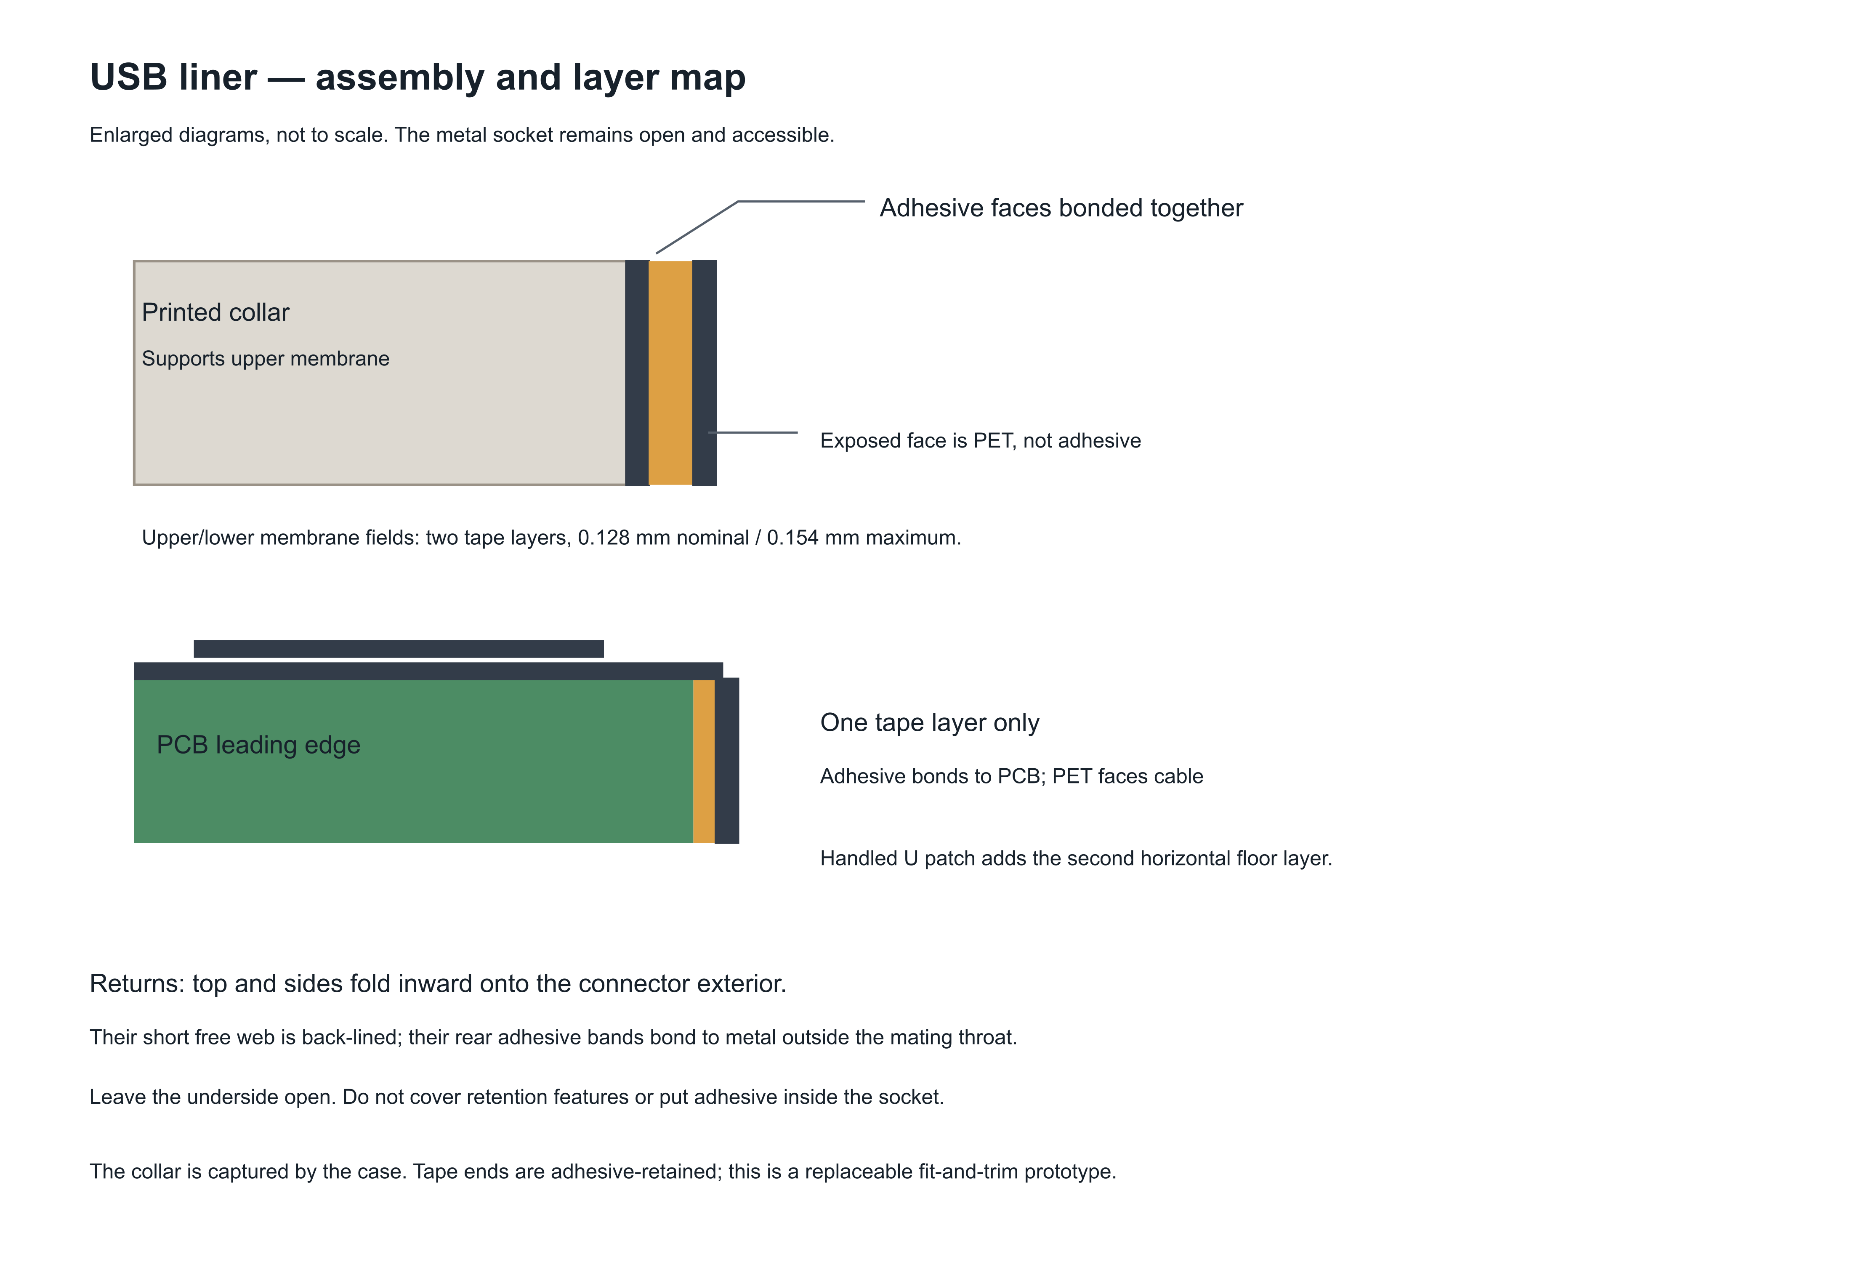

Check the layer transitions
The forward PCB-edge face receives one tape layer only. The added U patch lies on the horizontal floor and must not fold down onto that forward face. Unsupported membrane fields and return webs have two layers with adhesive faces together.
Keep free tape ends behind the socket mouth. Rear bands bond to the connector exterior; tape must remain clear of retention features, the mating throat and the underside of the soldered socket. Verify actual cable seating after closure.
Source: templates/usb/assembly-layer-map.svg, reproduced without changing its geometry or labels; USB-ASSEMBLY.md.

Prototype inspection record
Build ID __________________ Date __________________ Assembler __________________
Record Pass, Fail or Not tested, initials and evidence in the workbook. No result is pre-approved. Inspect open and closed assemblies; any failed check needs a recorded disposition and repeat inspection after rework.
ID | Stage | Acceptance check
Q01 | Incoming | Match v30 files and count 22 printed pieces, 20 inserts, 20 screws and 2 metal washers.
Q02 | Incoming | Record exact electronics, switch SKUs, insert geometry, filament and tape lots. Resolve substitutions before fitting.
Q03 | Printing | Confirm all five projects, saved profiles and supports; record actual print conditions and visible defects.
Q04 | Preparation | Remove supports and burrs; preserve pushers, hard stops, bearing faces, mounting lands and four volume tongues.
Q05 | Preparation | Confirm template scale bars, grille 46 x 46 x 0.50 mm R8, and correct gasket and adhesive thicknesses.
Q06 | Assembly | All inserts are flush at their mounting faces and cool; screws fit specified bearing faces without bottoming or distortion.
Q07 | Grille | Grille seats evenly; adhesive contacts supported perimeter; acoustic opening and screw-tip vents remain clear. Record coupon bond result.
Q08 | Speaker | Confirm spacer / tab / washer stack and acoustic seal. No gasket-induced speaker distortion.
Q09 | PTT open case | Press center and both ends. Switch clicks before cap stop and fully releases; links remain free and wires clear.
Q10 | Volume open case | Both switch bodies touch rigid rear lands; pads hold position without preload or axial motion.

Record actual printer settings, material lots, electronic part numbers, fastening process, adhesion coupon result and assembly photographs with the build. A nominal CAD dimension does not define a production tolerance.
Source: Checks adapted from ASSEMBLY.md, PRINTING.md and USB-ASSEMBLY.md for a new complete build.

Functional acceptance and disposition
ID | Stage | Acceptance check
Q11 | Volume open case | Press center and each end of each cap; verify electrical actuation and full return.
Q12 | Play open case | Confirm C carrier and C-0.40 retainer. Verify click, electrical actuation and complete release with actual switch.
Q13 | LED and mic | Retainer seats on hard lands without lead stress; microphone inlet and soft gasket are aligned and clear.
Q14 | USB | Single layer at forward PCB edge; no tape or exposed adhesive in throat, beneath socket, or across removable shell joint.
Q15 | USB | Record each cable tested, full seating, removal, snagging, opacity and liner condition after connection cycles. Record actual cycle count.
Q16 | Closure | PCB and battery are retained; complete approved harness is secured clear of mechanisms and edges. Shell closes without screw force.
Q17 | Closed case | Repeat PTT, volume and play center/end press and release checks; verify switch electrical operation after closure.
Q18 | Functional | Using confirmed electrical setup, record speaker sound, microphone pickup, LED response and USB function.
Q19 | Final inspection | Record grille adhesion, component retention, fit defects, deviations, photos and any required rework.
Q20 | Disposition | Record inspector, date and build ID; resolve failures and open procurement/electrical items before functional acceptance.

Inspection disposition
Inspector __________________________ Date __________________________
Disposition [ ] Accepted prototype [ ] Rework required [ ] Not evaluated
Open deviations and rework ___________________________________________________
___________________________________________________________________________
Acceptance applies to the recorded prototype and checked functions. It does not establish drop, fatigue, environmental or ingress qualification. Keep the completed record with the exact build files and component list.
Source: ASSEMBLY.md Physical acceptance; USB-ASSEMBLY.md fit checks. Blank fields are for the build recipient to complete.

Open decisions and verification scope

Items to close with the build team
O01 Electronics identification. Confirm PCB revision, battery, speaker, microphone, LED and all switch part numbers and electrical specifications. Timing: Before procurement and powered testing.
O02 Harness and firmware. Supply wiring schematic, pin mapping, wire lengths, connector details, strain relief, firmware and functional test setup. Timing: Before electrical assembly.
O03 Grille specification. Select alloy, finish, perforation pattern and supported bonding perimeter; drawing grid is illustrative. Timing: Before grille order.
O04 Bond and soft materials. Confirm gasket/foam grade and actual adhesive contact and bond strength on selected PLA+ and grille. Timing: Before assembly acceptance.
O05 Fastener process. Confirm head dimensions, insert source, insertion temperature/process and tightening method on a printed sample. No torque value is specified. Timing: Before repeat builds.
O06 USB fit. Qualify liner thickness, hand-trim, opacity, cable seating and wear on the actual hardware. Timing: Before functional acceptance.
O07 Button function. Validate travel, return, preload and center/end actuation on the assembled print. Define any cycle-life target separately. Timing: Before functional acceptance.
O08 Production criteria. Define tolerances, cosmetic limits, yield targets, durability/drop/ingress requirements and production process if proceeding beyond prototype. Timing: Before production release.

Verification supplied with the design
verification/RELEASE-CHECK.json reports passing native geometry, mesh, STEP and slicer checks for prototype readiness. native-and-mesh-check.json, assembly-audit.json and the five verification/printing/ folders contain the supporting records. These results do not establish physical return force, adhesive strength, acoustics or service life.
The source review notes a small existing speaker-root intrusion. speaker-aperture-probes.json preserves the nominal geometric evidence; acoustic performance still needs a physical check. Some source reports retain original workstation paths and historical report names. Use the included files, and do not treat absent historical paths as additional delivered evidence.

Fresh checks for this handoff
All 197 source manifest entries match SHA-256, covering all archived files except the manifest itself. All 21 binary STL files have exactly two incident triangles per mesh edge with consistent shared-edge directions. These checks establish file identity and edge closure; they do not rerun CAD fit or slicing and do not prove absence of self-intersections or physical performance.
The original source folder contains 198 files and has been preserved byte-for-byte. The new documentation, workbook and package index are Handoff H1. The root checksum manifest covers the final delivered files except the manifest itself.
Source: Fresh Source_Integrity_Check.json; supplied verification/RELEASE-CHECK.json, native-and-mesh-check.json, assembly-audit.json and independent-assembly-review.md.

